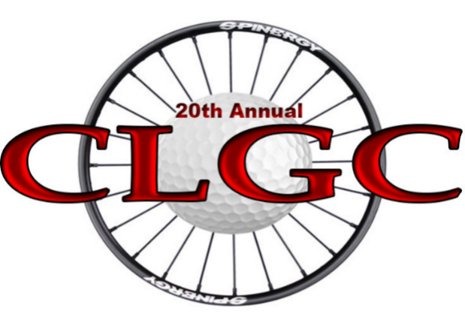
What is the Chris Lesanko Golf Classic (CLGC)?
At the age of 21, just a few days after being selected Bishops' Male Athlete of the Year, Chris sustained a life changing spinal cord injury, resulting in paralysis from the neck down, with no feeling or movement.
While undergoing his initial rehabilitation, Chris became frustrated with the methods and realized it was not going to be enough. After some research, he found a place in California called Project Walk, where they provided exercise therapy from head to toe, regardless of the level of injury. With the support from the CLGC, Chris was able to travel down to California three times over the course of six years. Chris then, with the help of his good friend, Owen, opened First Steps Wellness Centre (FSWC), in Regina. Unfortunately, the wellness services that FSWC provides is not covered through Saskatchewan Health, along with other specialized equipment and care costs associated with living in a wheelchair. The CLGC helps to offset these expenses for Chris.
Chris would not have had such great success and be where he is today without the exercise he received at Project Walk and continues to receive at FSWC. It is all because of the support of family, friends and complete strangers during the CLGC over the past two decades. This event not only provides financial assistance, but it helps Chris with his morale and mental clarity to greater improve his quality of life.
Please join us in ensuring Chris stays strong, focused and committed to his vision. Your generous support can be shown by selecting from the different options:
- Choosing a sponsorship level.
- Cash and/or prize donations (used for golf prizes, raffles and silent auctions).
- Golf, eat or purchase raffle tickets.
Bring your business crew out & have a GREAT time!
Your support guarantees Chris an opportunity to continue his dream and to achieve the independence he and others like him are striving for, something each of us takes for granted every day.

Thank you from Chris, his family and volunteers.
HOW CAN YOU SUPPORT CHRIS?
TASK SPONSOR: $150
Recognized Facebook, website & the program
HOLE SPONSOR: $250
Signage at course
Recognized Facebook, website & the program
PLATINUM SPONSOR: $550 ($650 value)
Hole & Task Sponsor
10 raffle tickets
20th ANNIVERSARY SPONSOR: $1300 ($1525 value)
Hole & Task Sponsor
20 raffle tickets
4 golfers & supper passes
Special requests from sponsor
CASH & PRIZE DONATIONS
Recognized Facebook/website & the program

GOLF TEAM: $750 ($840 value)
4 golfers & supper passes + 4 raffle tickets
GOLFER: $185
1 golfers & supper passes
SUPPER TICKET: $75
1 supper ticket
RAFFLE TICKET: $25
1 ticket to enter into draws!

PLEASE MAKE CHEQUES PAYABLE TO: Chris Lesanko Golf Classic, 47 Sangster Blvd, Regina, SKL S4R6L2
or E-transfer to: info.clgc@gmail.com Please visit www.chrislesankogolfclassic.com for all information- THANKS
REGISTRATION INFORMATION
​
CONTACT NAME: _______________________________________________________________

CONTACT EMAIL & CELL #: _____________________________________________________

BUSINESS OR GOLF TEAM NAME:________________________________________________

IF GOLFING - GOLFER NAMES:__________________________________________________

HOW WILL YIOU BE SUPPORTING CHRIS?
INDIVIDUAL GOLFER $185 TASK SPONSOR $150
TEAM GOLFING $750 HOLE SPONSOR $250
BANQUET TICKET $75 PLATINUM SPIONSOR $550
RAFFLE TICKETS $25/EACH ANNIVERSARY SPONSOR $1300
CASH DONATION: ____________ PRIZE DONATION:_____________

ALL INFORMATION CAN BE FOUND AT:
WWW.CHRISLESANKOGOLFCLASSIC.COM

PLEASE SEND E-TRANSFER TO INFO.CLGC@GMAIL.COM OR CHEQUE TO BE SENT TO:
CLGC
47 SANGSTER BLVD.
REGINA,SK
S4R6L2

